# Job Portal Database Project:

# Key Milestone 5:

**Group Members:**

M Afnan Khan 22pwcse2155

Mohsin Sajjad 22pwcse2149

M Hassan 22pwcse2105

1. **Finalized Conceptual Schema:**

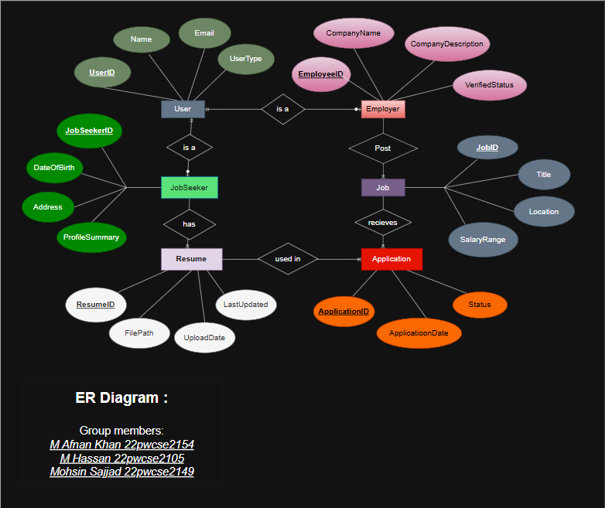

1. **Finalized Normalized Relations (This is must for SQL Projects)**

|  |  |  |  |  |
| --- | --- | --- | --- | --- |
| User_ID | Name | Email | Password | UserType |

**Employer**

|  |  |  |  |  |  |
| --- | --- | --- | --- | --- | --- |
| Employe_ID | User_ID | Company_Name | Company_Discription | Company_website | Verified_status |

**Jobseekers**

|  |  |  |  |  |
| --- | --- | --- | --- | --- |
| Seeker_ID | User_ID | Date_Of_birth | Address | Profile_Summary |

**Job**

|  |  |  |  |  |  |  |  |
| --- | --- | --- | --- | --- | --- | --- | --- |
| Job_ID | Employe_ID | Title | Description | Requirement | Location | Salary_range | Posted_Date |

**Resume**

|  |  |  |  |  |
| --- | --- | --- | --- | --- |
| Resume_ID | Seeker_ID | File_Path | Upload_Date | Last_Updated |

**Application**

|  |  |  |  |  |  |
| --- | --- | --- | --- | --- | --- |
| Application_ID | Job_ID | Seeker_ID | Resume_ID | Applied_Date | Status |

1. **SQL Database Tables and Querie**

**TABLES AND METADATA:**

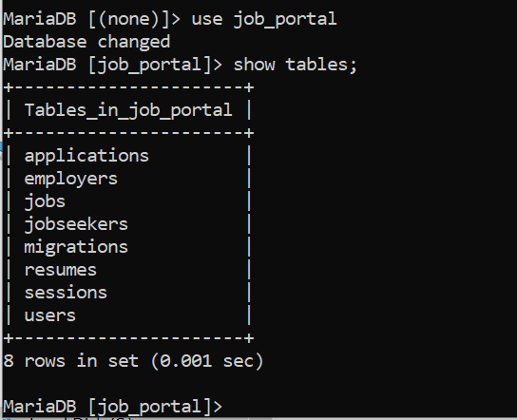

**USERS**

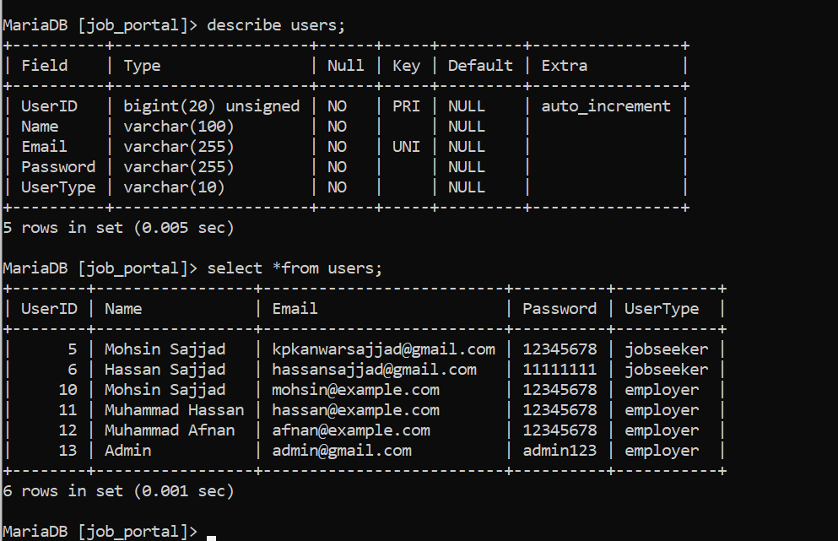

**Jobseeker**

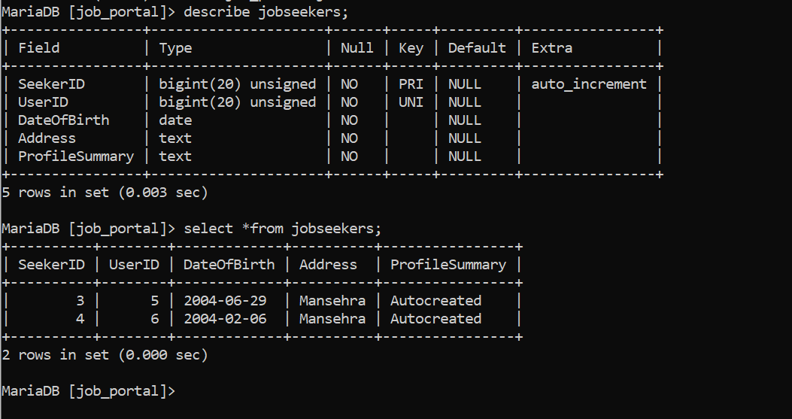

**APPLICATIONS**

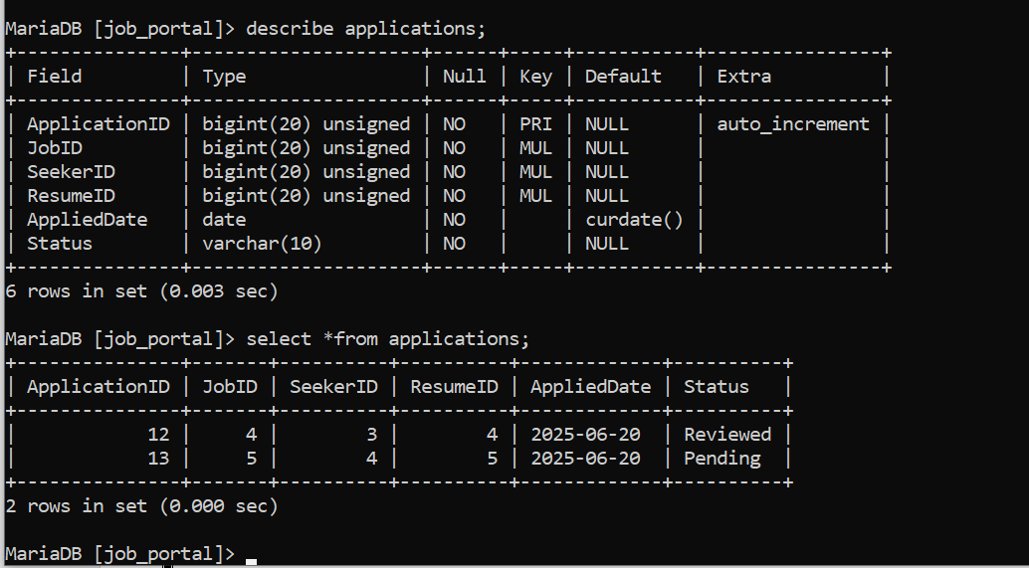

**EMPLOYERS  
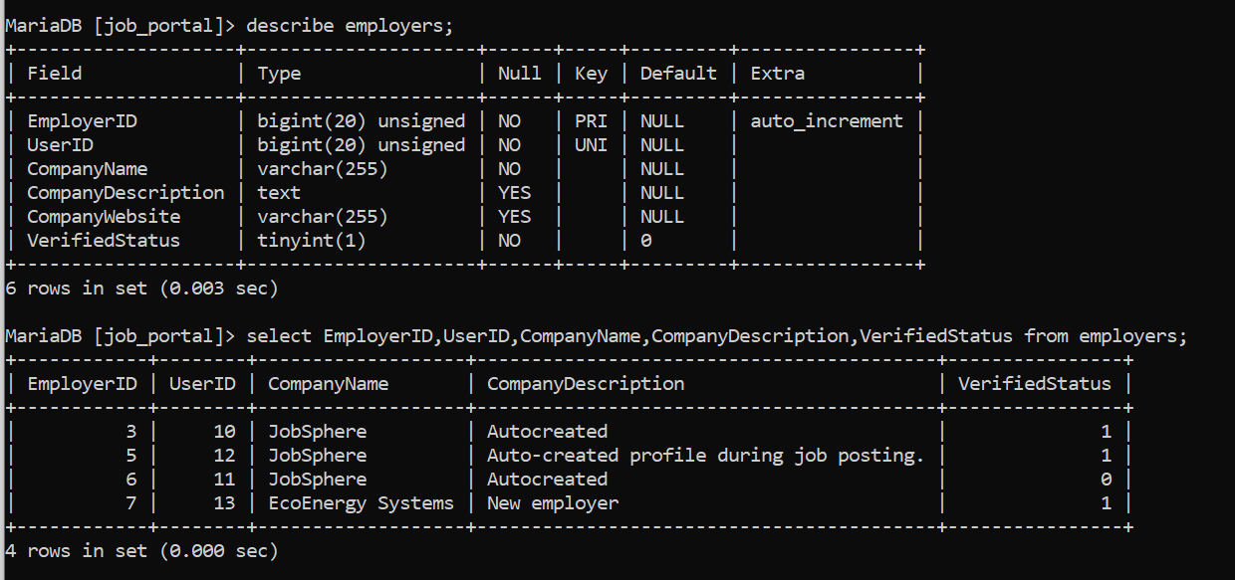**

**JOBS:**

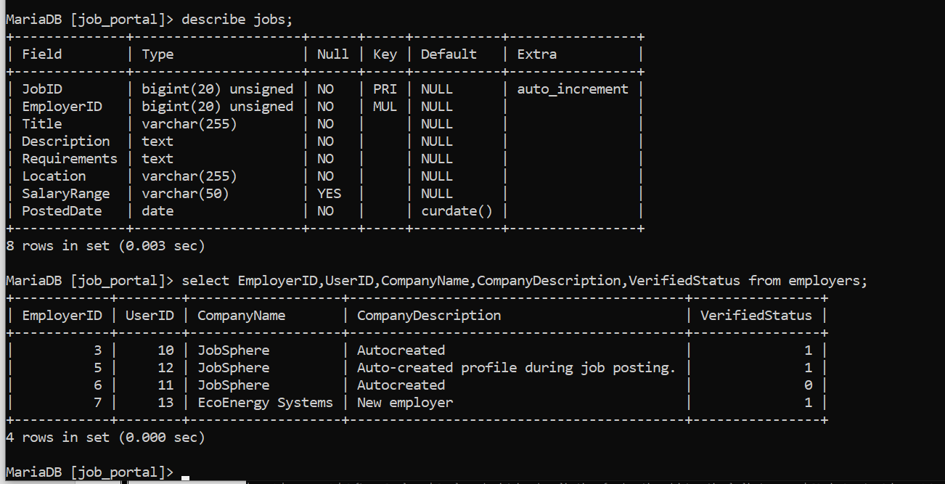

**RESUMES**

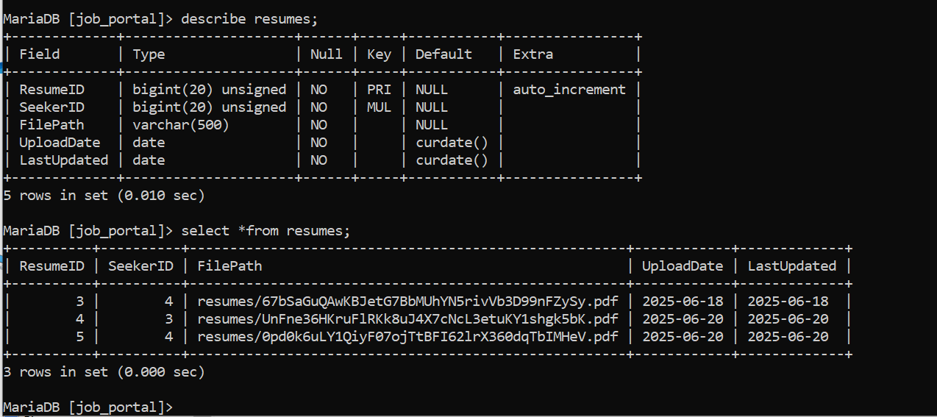

# SQL Queries

-- List all jobs posted by a specific employer

SELECT j.JobID, j.JobTitle, j.Location, j.PostedDate FROM Jobs j JOIN Employers e ON j.EmployerID = e.EmployerID WHERE e.CompanyName = 'XYZ Technologies';

-- List all applications for a specific jobseeker

SELECT a.ApplicationID, j.JobTitle, a.ApplicationDate, a.Status FROM Applications a JOIN Jobs j ON a.JobID = j.JobID WHERE a.JobseekerID = 1;

-- Retrieve jobseeker details along with their resume

SELECT js.FirstName, js.LastName, r.ResumeFilePath FROM Jobseekers js JOIN Resumes r ON js.ResumeID = r.ResumeID WHERE js.JobseekerID = 1;

-- Count number of applications per job

SELECT j.JobTitle, COUNT(a.ApplicationID) AS ApplicationCount FROM Jobs j LEFT JOIN Applications a ON j.JobID = a.JobID GROUP BY j.JobID;

-- List employers and the number of jobs they have posted

SELECT e.CompanyName, COUNT(j.JobID) AS JobCount FROM Employers e LEFT JOIN Jobs j ON e.EmployerID = j.EmployerID GROUP BY e.EmployerID;

1. **Comprehensive implementation details (Laravel)**

1. Project Setup

* Installed Laravel 12 using Composer.
* Configured .env file with MariaDB database credentials (job_portal).
* Ran php artisan migrate and created required tables manually or through schema.

**2. Authentication System**

* Created custom login and registration logic in AuthController.
* Session-based authentication using Laravel’s Session::put() and Session::get().
* Routes:

php

CopyEdit

Route::get('/login', [AuthController::class, 'showLoginForm']);

Route::post('/login', [AuthController::class, 'login']);

Route::get('/logout', [AuthController::class, 'logout']);

Route::get('/register', [AuthController::class, 'showRegisterForm']);

Route::post('/register', [AuthController::class, 'register']);

**3. User Roles**

* Registered users can be:
  + jobseeker
  + employer
  + admin (hardcoded user with special access)
* After registration, jobseekers and employers have associated entries created in jobseekers and employers tables.

**4. Dashboard & Navigation**

* Created a dashboard view that changes content based on user type.
* Added navigation bar with conditionally visible links:
  + View Jobs
  + Post Job (for employer)
  + My Applications (for jobseeker)
  + Profile
  + Logout

**5. Job Posting and Listing**

* Employers can:
  + Create new job postings via /jobs/create.
  + See list of jobs they posted.
* Jobseekers can:
  + Browse all job listings from /jobs.
  + Apply for any job.

**6. Job Applications**

* Created a system where jobseekers can apply for jobs.
* Employers can:
  + View applications to their jobs.
  + Approve or reject applications.
* Jobseekers can:
  + See their application status in the "My Applications" view.

**7. Employer Verification**

* employers table has VerifiedStatus field (0 = not verified, 1 = verified).
* Displayed Verified status in employer profiles.

**8. Admin Panel**

* Created an admin-only page (/admin) where:
  + Admin can verify employers.
  + View, add, or update employers.
  + View and change job application statuses.

**9. Blade Views**

* Created clean Bootstrap-based views for:
  + login.blade.php
  + register.blade.php
  + dashboard.blade.php
  + profile.blade.php
  + jobs/index.blade.php
  + applications/index.blade.php (for both jobseeker and employer)
  + admin.blade.php

**11. Database**

* **Main tables involved:**
  + users (UserID, Name, Email, Password, UserType)
  + jobseekers (SeekerID, UserID, ProfileSummary, etc.)
  + employers (EmployerID, UserID, Company info, VerifiedStatus)
  + jobs (JobID, EmployerID, Title, Description, etc.)
  + applications (ApplicationID, SeekerID, JobID, Status, etc.)
  + resumes (SeekerID (FK), FilePath, UploadDate, LastUpdated)

**Recommended Screenshots for Report**

1. Login Page

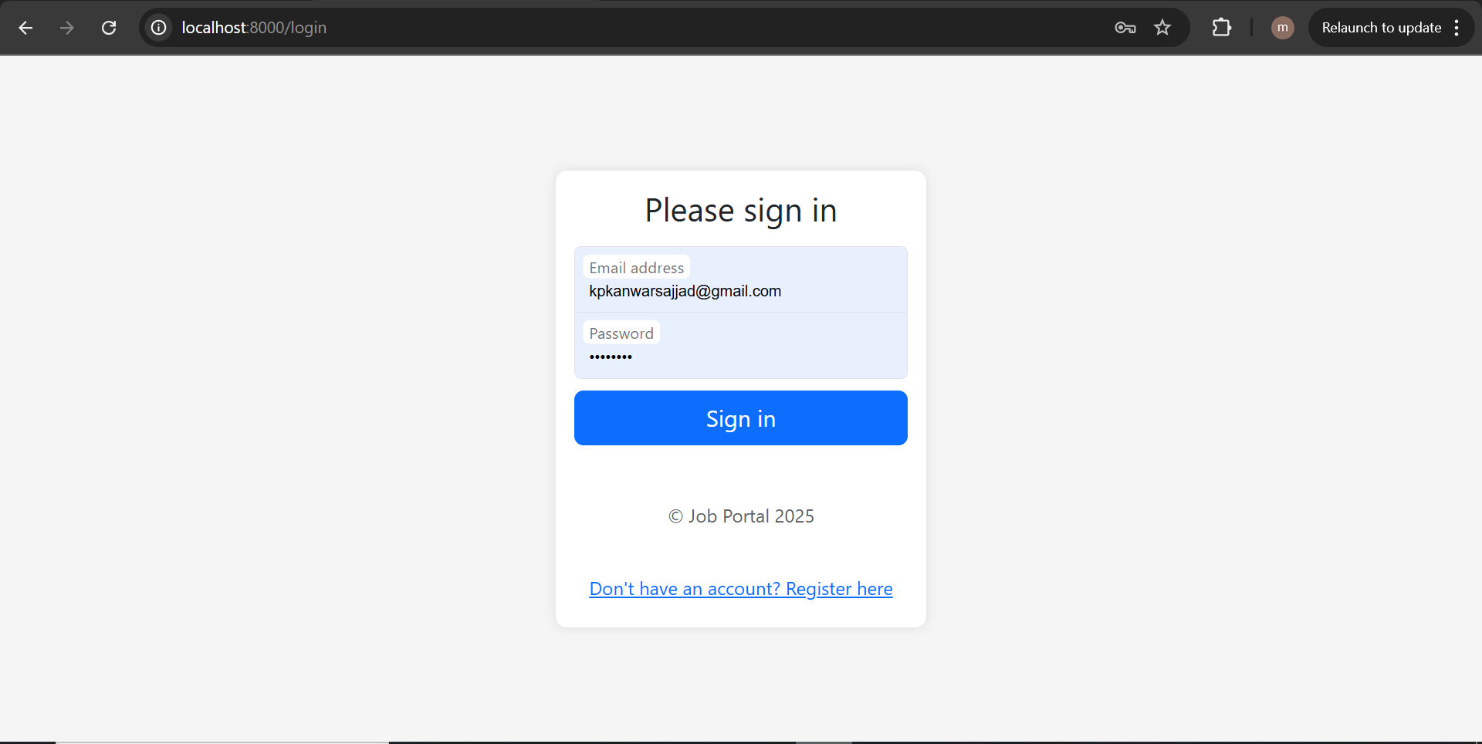

1. Register Page

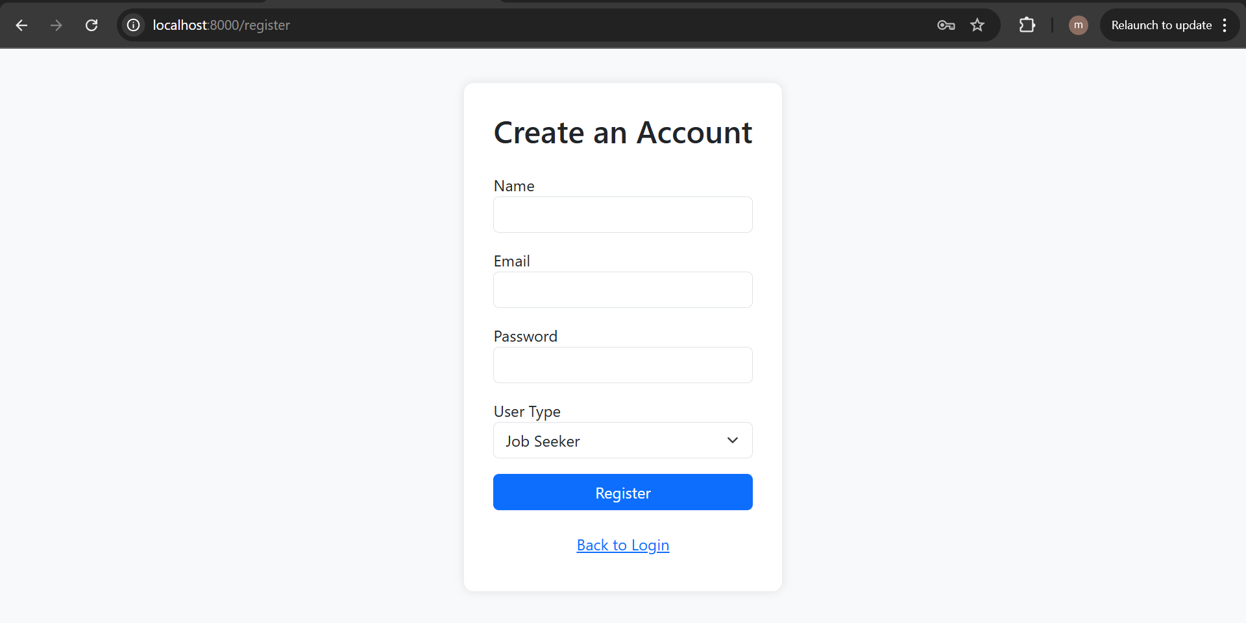

1. Dashboard (jobseeker view)

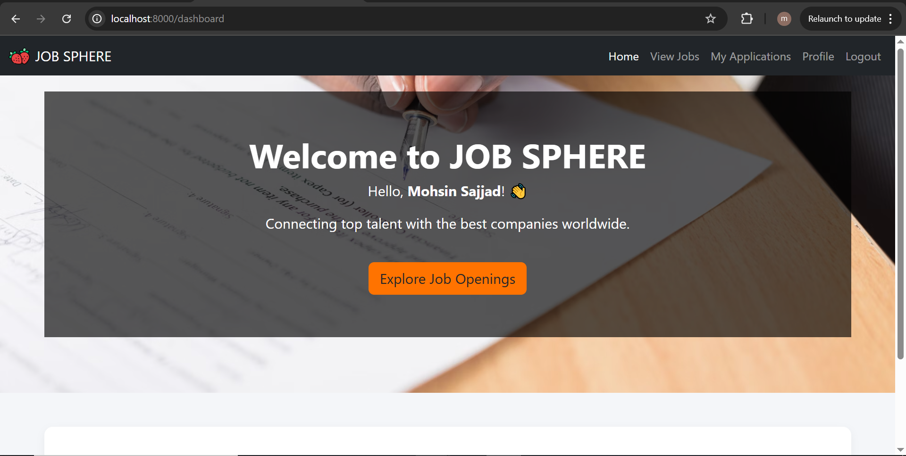

1. Dashboard (employer view)

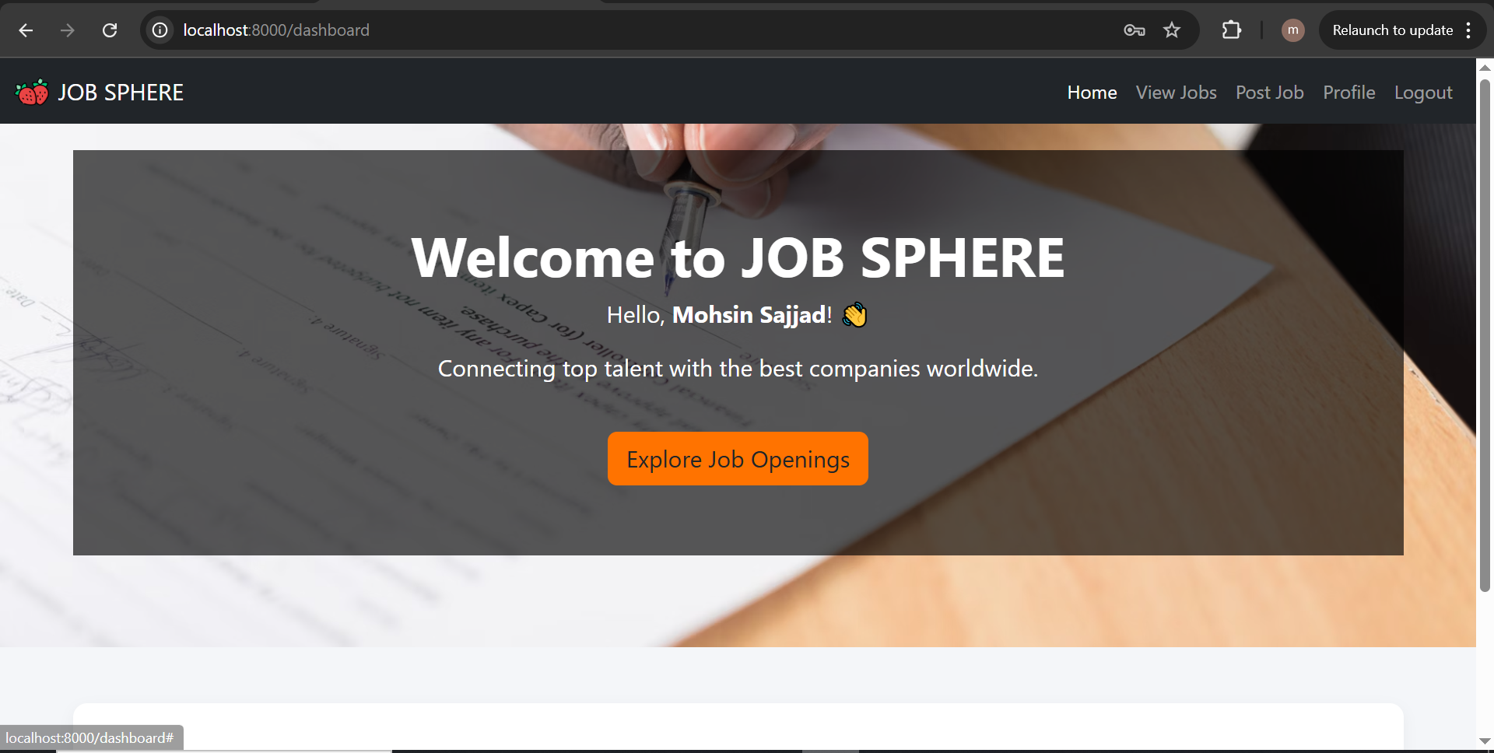

1. Job Listing Page

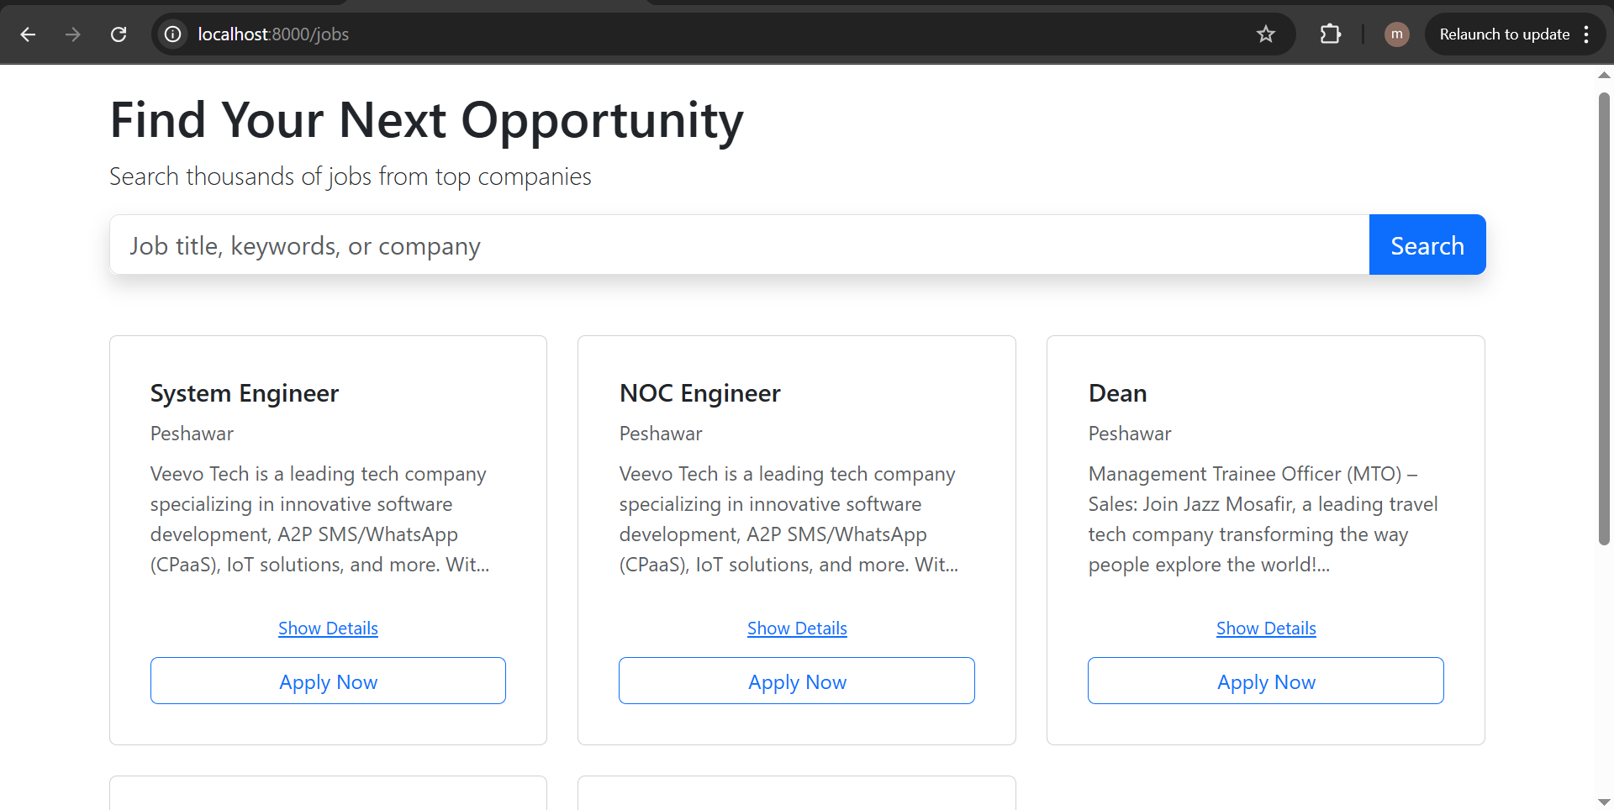

1. Job Creation Form

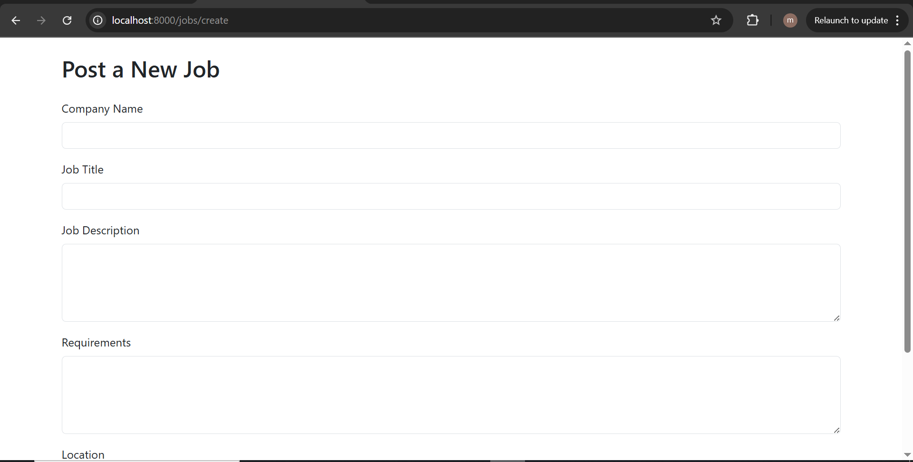

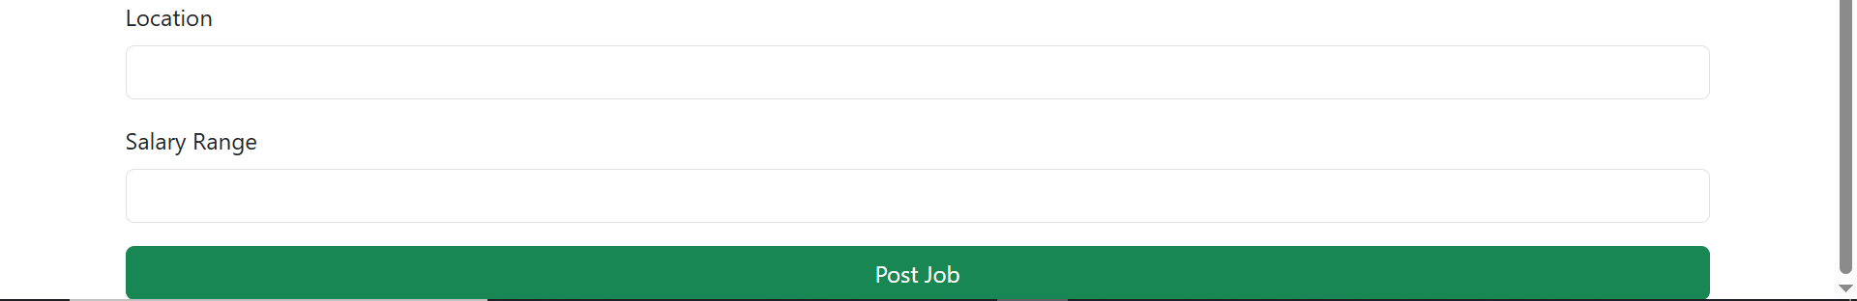

1. Application Submission Form

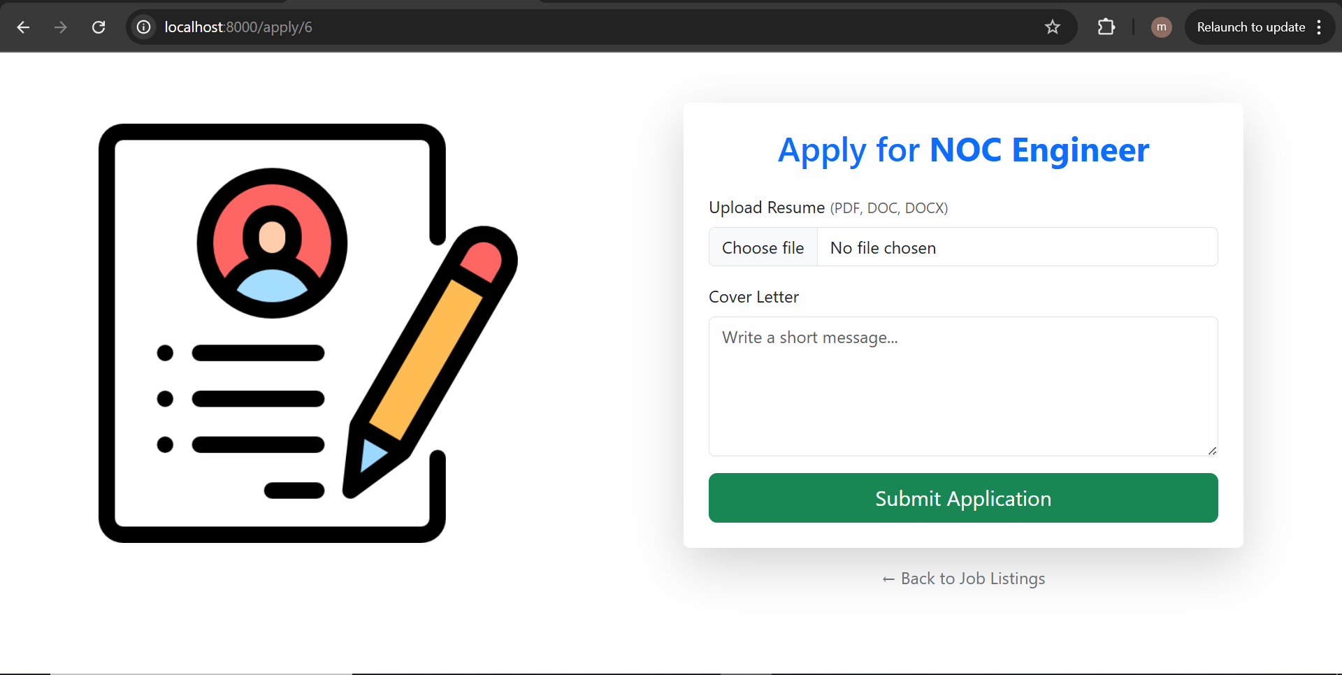

1. My Applications Page

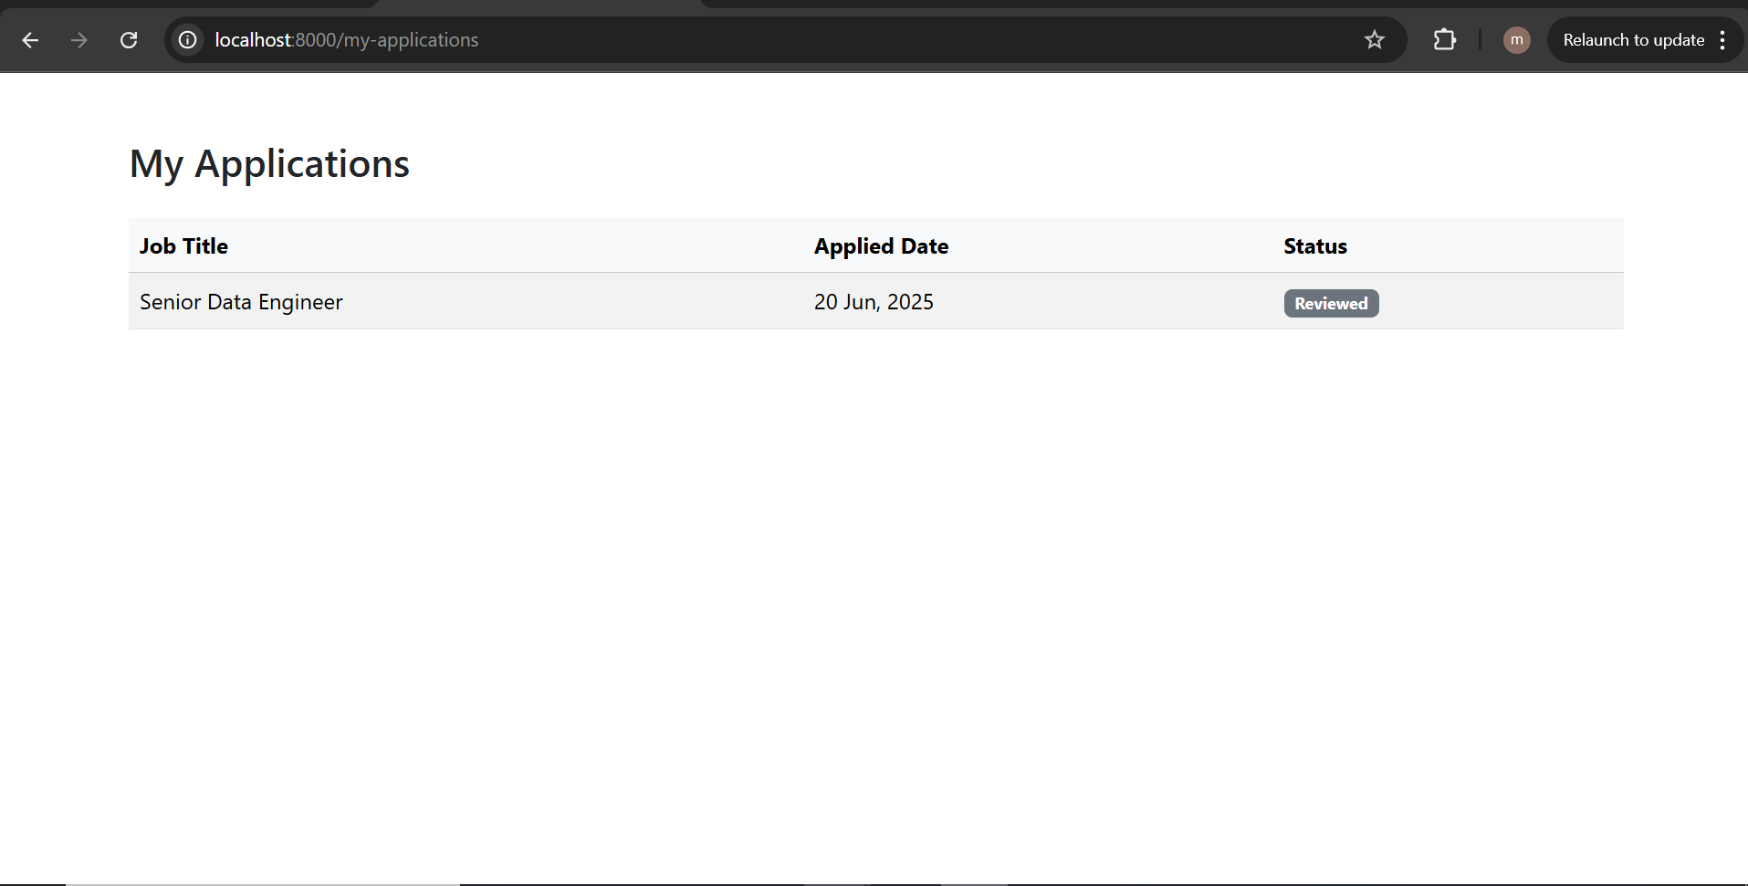

1. Employer Profile Page with Verified Status

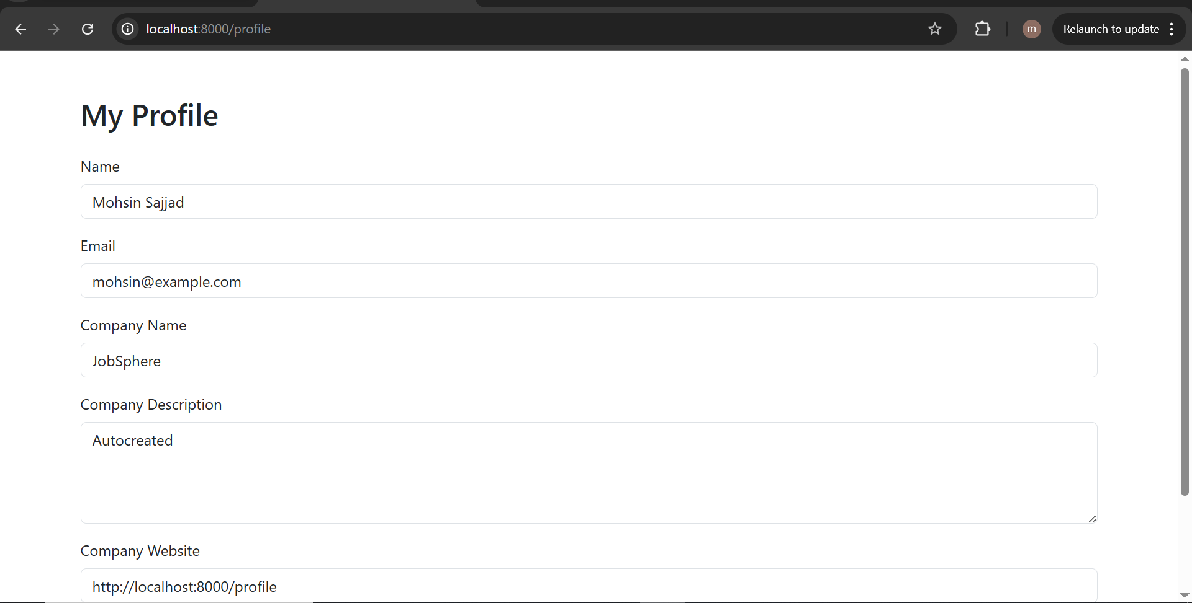

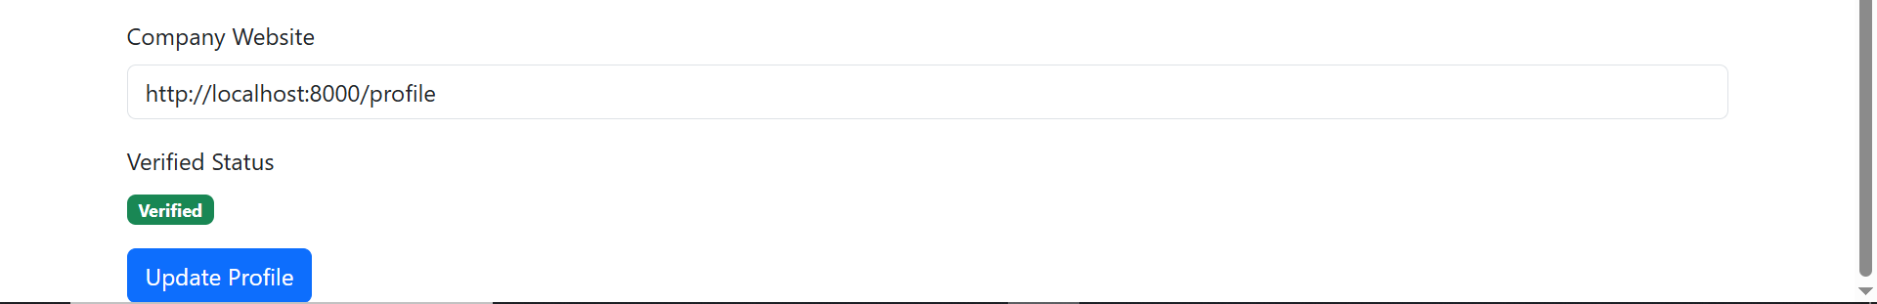

1. Admin Panel (Verify Employers + Application Management)

